

**9B21A022**

POLYCORP LTD.: A PRICING and INVESTMENT DILEMMA

Peggy Cunningham wrote this case solely to provide material for class discussion. The author does not intend to illustrate either effective or ineffective handling of a managerial situation. The author may have disguised certain names and other identifying information to protect confidentiality.

This publication may not be transmitted, photocopied, digitized, or otherwise reproduced in any form or by any means without the permission of the copyright holder. Reproduction of this material is not covered under authorization by any reproduction rights organization. To order copies or request permission to reproduce materials, contact Ivey Publishing, Ivey Business School, Western University, London, Ontario, Canada, N6G 0N1; (t) 519.661.3208; (e) cases@ivey.ca; www.iveycases.com. Our goal is to publish materials of the highest quality; submit any errata to publishcases@ivey.ca. i1v2e5y5pubs

Copyright © 2021, Ivey Business School Foundation Version: 2021-07-13

On a wintry morning in January 2016, Peter Snucins, founder and chief executive officer of Polycorp Ltd. (Polycorp), was looking out the window of his office at the Toronto skyline and Lake Ontario. He had a major pricing decision to make that would affect Polycorp, a private Canadian firm that served the mining, industrial, and transportation industries. The mining industry was facing a recession, and Snucins was receiving demands from customers for price cuts. However, a price cut could not only affect the firm’s profitability but could also limit the funds available for necessary new capital investments Snucins had planned to make for the firm.

Snucins spent much of his life as a merchant banker, so making important financial decisions was not new to him. Still, the decision was not trivial: the mining sector represented almost half of Polycorp’s sales (see Exhibit 1). Margins on sales to the mining sector were the company’s strongest, and they had grown from just over 20 per cent of revenues in 2012 to over 42 per cent by 2015. The mining sector had also provided Polycorp with its main opportunity for growth. Polycorp’s export sales accounted for over 78.3 per cent of sales, an increase of almost 56.0 per cent since 2012. The world market for mill liners, Polycorp’s primary product for the mining sector, equated to sales of over US$1 billion[1] per year. Africa, the Russian Federation, and South America presented the highest opportunities for growth.

In recent years, Polycorp had become a global leader in providing protective rubber liners for grinding mills used in mining operations. The company had installations at more than 400 grinding mills worldwide. The liners were superior to those of competitors in controlling corrosion, abrasion, noise, and vibration. Polycorp, therefore, had been able to charge premium prices due to its proprietary technical advances, its superior customer knowledge and service, and its favourable reputation in global markets.

As Snucins explained, “While the underlying technology is highly engineered and incredibly sophisticated, the essence of what happens in a mining mill is that big rocks go in a large steel cylinder and small rocks come out.” The liner that Polycorp sold was what protected the mill, mitigated the wear and noise, and increased the throughput. But Snucins knew that it was not only the technology that helped explain the success of his business. Mill linings were consumables. The company, therefore, had a recurring revenue stream since liners had to be replaced every three to twelve months, depending on the application. In other words, “this business is a lot like selling razor blades for a razor,” said Snucins.

The company had ambitious plans, and, as a whole, expected to reach $150 million in sales by 2020. To keep pace with this growth, primarily in the mining division, Polycorp had made plans for $20 million in capital expenditures over the next five years (see Exhibit 2). Its plant in Elora, Ontario, Canada, was at capacity, to the point where its employees even had trouble finding places to park their cars in the plant lot. Pricing decisions for the mining division could affect the plans for capital expenditures.

Snucins was optimistic about the future of Polycorp, but he would have been a fool if he had not considered the state of the mining industry when determining the mining division’s pricing strategy. In late 2015 and early 2016, the business sections of international newspapers had been full of stories about mine closures and dropping world demand for resources such as iron ore, nickel, and copper. In 2015, the *Guardian*, for example, reported that weaker demand from China, the world’s biggest consumer of raw materials, caused commodity prices to fall to levels not seen since 2009. Mining groups, in particular, felt the pain. As an illustration, the *Guardian* told the story of Anglo American plc’s Minas-Rio operation in Brazil. The project was conceived when iron ore sold at US$150 per tonne. Anglo American spent US$8.4 billion to build the Minas-Rio mine and supporting infrastructure, but then the price of iron ore fell to US$50 per tonne. The operation’s value fell to only US$3.6 billion, far below the cost of the investment.[2]

The *Financial Post* reported that since the drop in commodity prices was expected to last for a number of years, Anglo American intended to sell 60 per cent of its assets and cut 85,000 jobs from its workforce of 135,000.[3] Other mining giants like Rio Tinto Group, Vale SA, Kinross Gold Corporation, and Barrick Gold Corporation experienced similar losses. Mining executives blamed each other for overinvesting and overproducing at the peak of a cycle. In light of these events, mining operators worldwide looked for significant cost savings by cutting capital spending and reducing the cost of all inputs. They also sought productivity gains.[4]

Polycorp’s Background

Polycorp was the successor to B.F. Goodrich Engineered Products of Canada, a massive group of buildings that occupied the downtown core of Kitchener, Ontario, for almost 100 years. The parent company, B.F. Goodrich, was the first company to discover how to bond rubber to steel, and it was the first company to line mills with rubber. Over the years, the company increasingly concentrated its efforts on its US-based aerospace business, regarding the Canadian division only as a source of income and making little investment in the business. As cash became tight at the Canadian division, many of its customers complained of poor service. Not surprisingly, the business languished, its reputation declined, and it ultimately went bankrupt, resulting in its assets eventually being controlled by the Government of Ontario.

Despite this rocky history, Snucins saw an opportunity and believed he could revitalize the business and make inroads into underserved, worldwide niche markets—markets that were segments of larger markets but defined by their own unique or specific needs, preferences, or identities that made them different from the markets at large. Niche markets could be defined by numerous characteristics, including price (premium, moderate, discount), level of quality (superior/high, average, inferior/low), geography, or industrial sector.[5] Many of Polycorp’s larger global competitors were diversified firms competing in multiple product markets; they produced both mining mills and ancillary products for the mining industry. But Polycorp focused only on producing high quality, premium priced mill liners.

Snucins also believed that, if he created a company that could provide better service and that designed and manufactured better products, “the world would be his oyster.” In other words, he thought Polycorp’s business opportunities were unlimited. Competitors had allowed their intellectual property to become stale. Although the reputation of the Canadian company had been damaged by years of neglect, Snucins believed it could be restored since Canada was highly regarded for its expertise in the mining sector.

In 1996, Snucins’s vision was realized and Polycorp was established when he acquired the assets, patents, and intellectual property of the former B.F. Goodrich division. He kept the best of the technologies from the operation and the best employees. They had many years of rubber manufacturing experience. His acquisitions combined 160 years of heritage, knowledge, and formulas under the Polycorp name.

Polycorp established a state-of-the art, 5,100 square metre, ISO 9001–certified manufacturing facility in Elora, about an hour and a half northwest of Toronto. All of the company’s products were produced in this modern facility, which used state-of-the-art manufacturing procedures. Engineering, customer service, sales and marketing, and product development for each of the divisions also shared this location. Some of the company’s senior management team were located in its Toronto headquarters. Operations were lean, and the company employed just over 170 multi-skilled people. Polycorp took great pride in providing customers with quality polymer solutions that were customized to fit their unique requirements.

Snucins believed that B.F. Goodrich had overdiversified the firm, partially causing the failure of the Canadian business. It had offered over 600 stock-keeping units. Therefore, Snucins decided to focus his firm on only three related strategic areas: grinding mill liners for the mining industry, protective liners for the industrial market, and track encapsulation systems for the transportation and light rail markets (see Exhibit 3). All three markets were linked by their need for some type of protective polymer product. Each division served niche markets with significant barriers to entry. Each was characterized by recurring revenue streams. Over time, Polycorp developed many specialized products and processes that were benchmarks for quality and reliability in the three sectors in which it competed. Eventually, Polycorp became the largest manufacturer of rubber linings in North America.

From its inception, Polycorp had been an extraordinarily successful Canadian private company. It experienced rapid growth in sales and profits. Polycorp’s success and the quality of its service and products were validated by the many awards it and its founder received. For example, it was recognized by *Profit* magazine as one of Canada’s fastest growing companies in 2013, 2014, and 2015. The company was listed among Canada’s best managed companies. It received the Ontario Export Award for the services sector and Grant Thornton LLP’s Private Business Growth Award. During the latter award ceremony, Phil Noble, executive partner and CEO of Grant Thornton, lauded Polycorp, saying, “Polycorp Ltd. is a great Canadian success story built on a solid, long-term strategy and a commitment to technical leadership. . . . By constantly engineering new designs, developing improved materials and composites, and searching for new technologies, Polycorp Ltd. has positioned itself for remarkable and sustained growth and is a business model for others to follow.”[6]

Polycorp’s revenues and profits had grown rapidly and consistently over the years. In 2015, it achieved earnings before interest, taxes, depreciation, and amortization (EBITDA) of $18.4 million on sales of $87.1 million. The company had budgeted to generate increased sales and profits in 2016.

Despite its success, Snucins knew that the firm was now facing a major challenge. The mining industry was dealing with an unprecedented downturn. Mine operators were demanding significant price concessions from their suppliers, and Polycorp’s competitors were reducing their prices. Snucins wondered if he would be able to sustain Polycorp’s pricing to maintain the high margins the company had earned up to the time of this industry crisis. He had hoped for continued sales growth and could not forget that Polycorp needed to invest in and support its advanced research and product development.

Polycorp’s Strategy

Polycorp’s aim was to achieve a dominant market position in sustainable and defensible niche markets that had significant barriers to entry. It was committed to being a leader in these niche markets, a position it had achieved by being able to differentiate itself from competitors.

Polycorp first established itself as a product leader in the North American mill liner market. It then used this base as a platform for product line extension and geographical expansion.[7] It looked for markets that faced the same issues as those Polycorp had addressed in North America. The company especially targeted markets underserved by its competitors, and it actively serviced harsh and even dangerous jurisdictions like the Republic of Mali, Burkina Faso, and the Democratic Republic of the Congo. By 2016, Polycorp served mining companies in 52 countries, and it worked on every continent except for Antarctica. It had an established reputation for reliability, consistency, and high quality.

To help realize its strategy, Polycorp focused on four major competencies: (1) superior, innovative products made using the company’s leading edge technologies; (2) in-depth customer knowledge that helped Polycorp create customized total solutions and superior value for its customers; (3) talented employees with advanced technical expertise who were empowered to innovate, solve problems, and provide excellent service; and (4) superior, always improving, manufacturing and quality control processes.

(1) Superior Products and Technologies

Snucins described Polycorp’s business approach in an interview for *Manufacturing Today*: “What we do is to create products that have more value for end-users with higher quality and enhanced performance.”[8] Polycorp’s products—moulded products like mill liners—had to withstand wear from sliding rock and harsh, repeated impact. These protective linings for mining mills were also exposed to acids, alkalis, and abrasives through a wide range of temperatures (see Exhibit 4). In order that the linings meet such rigorous demands, Polycorp invested heavily in research and development. This led to the creation of Polycorp’s superior rubber formulations and technical designs. These, in turn, were translated into high quality products and superior innovations that were valued by Polycorp’s customers.

The rubber liners that Polycorp developed had many advantages over traditional steel mill liners. They reduced customers’ maintenance costs, and they were faster and safer to install. The liners were also better at reducing noise, which improved worker safety and well-being; they reduced leakage from the mill; and they were ideal for older mills. Mill liners could be designed to last anywhere between three months for aggressive applications to a couple of years in smaller mills.

Polycorp’s liners had a longer life and more predictable wear-rates than liners produced by competitors. It was critical that mill liners achieved their required service life. Mines used preventive maintenance schedules to plan for replacement of the mill liners. If wear estimates were off by even a week, the entire mine operation had an unplanned shutdown, which would cost in excess of $75,000 per hour.[9]

The company’s liners were also lighter in weight, which reduced stress on the mill. More importantly, their lighter weight reduced energy costs by up to 80 per cent. Energy was the highest cost borne by mine operations; thus, even small improvements, in the range of a 1–2 per cent reduction, amounted to significant cost savings for customers since large scale mine operations ran 24 hours a day, seven days a week. Even though Polycorp charged a higher purchase price than its competitors, the advantages associated with its liners resulted in a lower total cost per tonne for milled ore for its customers.

Despite Polycorp’s technical expertise, Snucins had never viewed his company as an engineering and manufacturing company. He saw it as selling insurance—insurance that helped its customers mitigate their risks arising from impact, corrosion, abrasion, noise, and vibration.

Polycorp developed and owned all of its formulations. Since high quality products and proprietary knowledge were key to its success, Polycorp protected its intellectual property with patents on product enhancements and process improvements. In 2016, Polycorp had 23 active patents and 16 patent applications were pending. Many of these had been filed in multiple jurisdictions.

(2) In-Depth Customer Knowledge

Polycorp was focused on knowing its customers, understanding their needs, and creating value for them. The company used its knowledge of customers to enhance customers’ growth and prosperity. It was committed to long-term relationships with its customers; it placed high value on customer feedback and involved customers in the design of new products (i.e., collaborative innovation).

Customer intimacy helped Polycorp understand trends affecting its customers. The insight enabled the firm to develop materials and products that could be custom designed to meet individual customer requirements. For example, Polycorp saw the trend toward the use of larger mills that had to operate cost effectively in increasingly harsh conditions. These trends elevated customers’ expectations for performance of the mill liners they purchased.

Since the cost of installing new mills was tens of millions of dollars, customers were demanding. Mines paid $500,000 to $1.5 million for liners to protect their mills. In-depth customer knowledge enabled Polycorp to provide its customers with total customized solutions that increased customers’ productivity, reduced their maintenance downtime, and helped them solve complex problems.

(3) Talented, Empowered Employees

Polycorp did not just rely on its high quality and unique products to ensure it had a competitive advantage. Snucins always stressed that products did not develop themselves. Talented, motivated, and engaged people were at the heart of the company’s success.[10] For example, designing a rubber compound to withstand the harsh environments faced by Polycorp’s customers in the mining sector required chemists with extensive experience and knowledge. Polycorp also took advantage of its proximity to the University of Waterloo and other universities to recruit top students to the firm. Hiring and retaining the best people were a priority for Polycorp.

The company empowered plant employees and its global network of agents to take action to ensure product quality and performance. Polycorp prided itself on its after-sales support and rapid response time to any problems that might arise with any of its installations. The company had over 50 agents and distributors located around the world, who serviced every continent.

(4) Superior Manufacturing and Quality Control Processes

Over the years, Polycorp purchased state-of-the-art equipment to enhance its productivity and manufacturing capacity. The company was also committed to continuous process innovation. For example, over the previous four years, as Polycorp became more design and technology intensive, it developed computer models to simulate the flow of ore slurry through grinding mills. This insight helped its customers optimize their mill design to result in longer useful mill life, increased throughput, and mill efficiency.

Polycorp was also unswerving in its desire to reduce its environmental footprint through various investments focused on reducing and recycling scrap, using and developing “greener” inputs, developing more sustainable products, and reducing energy use. To support these objectives, the company supported and partnered with GreenCentre Canada at Queen’s University, part of the Networks of Centres of Excellence of Canada. Polycorp also partnered with the Materials Technology Institute Inc., a not-for-profit technology development organization, and it leveraged its on-site lab resources to advance solutions in key areas. The company also supported students conducting mining research at a number of universities.

Competition

The advice Snucins gave to other entrepreneurs was, “The world is our marketplace, but the world is also our competitor.” Polycorp’s most successful endeavours had been in North America, Africa, the Russian Federation, and South America. After 20 years of effort, it had begun to penetrate China through its office in Beijing. Global marketplaces not only created the potential for more sales but also served as sources of the knowledge and benchmarks that Polycorp used to continuously improve its products and operations.

However, as the company grew, it attracted the attention of competitors who used aggressive pricing to try and dislodge Polycorp (see Exhibit 5). All of its competitors provided mill liners at lower cost than Polycorp. Two new entrants in the international marketplace were large, diversified Chinese competitors, CITIC Ltd. and Naipu Mining Machinery Co. Ltd (Naipu). Along with one of the more established firms—the Indian competitor, Tega Industries—they offered products priced 50 per cent lower than Polycorp’s prices. These competitors also offer extended payment terms as well as consignment inventory.

Polycorp believed its greatest competition came from three established international manufacturers of rubber mill liners: Metso Minerals (Metso),[11] Tega Industries Ltd. (Tega), and the Weir Group plc (Weir). All three companies were much larger, more diversified players than Polycorp.

Metso Minerals

The international industry powerhouse was publicly listed Metso, a Finnish company headquartered in Helsinki. One of the oldest and biggest firms, it described itself as “a frontrunner in sustainable technologies, end-to-end solutions and services for the aggregates, minerals processing, metals refining, and recycling industries globally.”[12] Its mining division offered a full range of products used in the mining industry, from mills and mill liners to conveyors. It generated €2,198[13] in sales revenues in 2015 and its services business accounted for 65 per cent of these sales (see Exhibit 6).

Metso supported its customers with a global network of 80 service centres staffed by 6,000 professionals. It employed another 11,000 persons who worked in the 50 countries that represented the company’s markets. Europe (25 per cent), North America (22 per cent), and South and Central America (20 per cent) represented Metso’s largest markets, followed by Asia Pacific (17 per cent), Africa and the Middle East (10 per cent), and China (6 per cent).[14]

Until 2015, Metso was a highly diversified company; then it sold off units so it could focus on the mining, aggregate, and oil and gas industries. While its 2015 annual report stressed that Metso aimed to be the leading provider in all its businesses, its mining division generated 54 per cent of the orders it received.[15] The company’s strategy continued to be focused on growth, which it hoped to achieve by capitalizing on its installed base and finding new markets. Metso expected commodity prices in the mining sector business to remain weak in 2016; therefore, it planned to focus its efforts on reducing costs and optimizing production while reducing its capital expenditures. Metso also expected that the demand for mining equipment would remain weak but the demand for mining services would remain satisfactory.[16]

Metso’s business drivers in the mining sector included the belief that the declining grade of most ores would require that more ore be processed. Technology improvements (including digital improvements) would be needed, along with sustainable and energy-efficient solutions. Retrofit solutions would also be needed to prolong the lifetime of existing mining equipment. Like many manufacturers of mining mills, Metso started to move away from manufacturing capital goods like mining mills themselves to manufacturing consumables like mill liners. Metso made a higher margin on the mill liners than it did on the mills themselves.[17]

Tega Industries Ltd.

Tega was a privately held Indian company headquartered in Kolkata. It initiated an aggressive international expansion in 2011 after a US private equity company, T.A. Associates, based in Boston, purchased a 15 per cent stake in Tega for US$40 million.[18]

Founded in 1976, Tega described itself as a “global leader in the design and production of consumables” for the mining and mineral processing industries. It stressed that it provided “technical and economically unrivalled [that is, the cheapest] solutions to complex problems in mining . . . material handling,” and other areas.[19]

Tega was one of the largest global manufacturers of mill liners, which it saw as critical components in driving efficiency and lowering miners’ cost per tonne of operation. It had manufacturing facilities in India, South Africa, Australia, and Chile and exported its products and solutions to 72 countries. It had a network of sales and distribution offices in 16 countries, including Canada, and had more than 1,600 employees located around the globe.[20]

As a private company, Tega’s exact revenues were unknown, but a report estimated the company earned between $100 million and $500 million annually.[21]

The Weir Group plc

Weir was an engineering company founded in 1871 and headquartered in Glasgow, Scotland. It eventually became a public company listed on the London Stock Exchange. Weir was diversified, with 14,700 employees located in over 70 countries serving three markets: mining (60 per cent), infrastructure (23 per cent), and oil and gas (17 per cent). It created value by producing mission-critical solutions and offering trusted technology, services, and highly engineered equipment. Weir offered intensive aftermarket care and comprehensive global support.[22]

The largest markets for Weir’s minerals (mining) division were in North and South America, followed by Europe, Asia Pacific, the Middle East, Africa, and Australia. Its revenue varied widely by ore type, with copper representing 24 per cent; gold, 12 per cent; iron, 7 per cent; coal, 5 per cent; and other mined minerals, 24 per cent. In addition to selling mill liners and corrosion protection equipment, the company’s mining division offered a range of crushing and grinding equipment as well as mining dewatering systems, slurry transportation, and tailings management. Its rubber mill liners were custom designed to each mill and made with premium compounds that offered outstanding wear resistance, reduced maintenance costs, and decreased mill downtime.[23]

Like Polycorp, Weir believed that 2016 would be a challenging year for its mining division. Revenues for the division had already fallen by 4 per cent, and its profits by 9 per cent, in 2015 (see Exhibit 7). The company’s strategic goals were to strengthen and extend its addressable markets and attain the status of “partner of choice” for its products and services. It saw ongoing risk arising from commodities like copper, but it foresaw good long-term growth prospects for this ore since it required the most processing and aftermarket support, which fit well with Weir’s business model. Since the grade of copper ore was projected to decline by 17 per cent over the next 10 years, more ore would need to be processed, and this would lead to significant wear and tear on equipment and mill liners. This, in turn, was projected to generate valuable aftermarket revenues for Weir’s spares and for the servicing departments of its mineral division.[24]

Other Competitors

In addition to its three large competitors, Polycorp monitored a host of other potential competitors.

*Mill Manufacturers*. Some firms, like Outotec Oyj[25] and FLSmidth & Company A/S, traditionally focused on manufacturing mining mills, which were expensive capital goods representing a significant capital investment by mine operators. However, these companies had added mill liners, a consumable, to their set of product offerings.

*Fragmented, Local Competitors*. Small competitors existed in every region. For example, local manufacturers like SIOM Minería SpA operated in South and Central America; Multotec Pty Ltd. was located in South Africa; and a multitude of legacy steel liner manufacturers existed in the post-Soviet states.

*New Entrants*. New rubber liner manufacturers had entered the industry. These included CITIC, which was part of CITIC Group Corporation Ltd.,[26] one of China’s largest state-controlled conglomerates. The company initially made mining mills and had recently migrated into the manufacture and sale of mill liners. Another new entrant in the mill liner market was the Chinese manufacturer Naipu, which was aligned with Chile-based metal lining company Electro Metalúrgica SA (ME Elecmetal).

*Steel Liner Manufacturers Adding Rubber Liner Capabilities*. The biggest and most profitable segment of the mill lining market was liners designed and installed for the largest mills, which had the harshest applications. The cost per liner was the highest for this type of mill, and the liner life was the lowest. Sales to companies with large mills resulted in significant recurring cash streams for suppliers like Polycorp and its major competitors. Historically, only steel was considered for use by this segment; however, in the previous decade, rubber and rubber-metal combinations had been developed, trialled, and successfully installed. This change took market share away from manufacturers producing steel liners. To address this market loss, traditional steel liner suppliers, like Bradken (recently purchased by Hitachi Construction Machinery Co. Ltd.)[27] and ME Elecmetal from Chile, had developed rubber mill liners or purchased rubber liner manufacturers, which enabled them to migrate from the steel liner segment of the marketplace to the rubber liner segment.

The Decision

Given the increasing competition and the challenges facing the mining industry, Snucins needed to seriously consider his options for a pricing strategy that would take Polycorp’s mining division successfully into the future. He was pleased that the company had been able to increase the margins on rubber mill liners to 42 per cent while still increasing sales (see Exhibit 8). Nonetheless, he wondered if now was the time to cut prices. The company’s competitors were all priced significantly lower, which appealed to many customers struggling with the low prices they received for the minerals they sold.

Cutting prices would be contrary to Polycorp’s track record to date. It was not a trivial decision since a cut in margins could pause some of the company’s capital expenditures. Price cuts would also limit Polycorp’s ambitious plans for further international expansion, and lower margins would constrain the company’s high-priced marketing initiatives. Further, if he were to cut prices, Snucins wondered if volume sales would increase enough to offset the price cuts. Even more worrying was how Polycorp’s competitors might react.

To help clear his mind, Snucins jotted down some alternatives:

* Cut selling prices immediately by 20 per cent.
* Undertake selective price decreases where competition was most fierce.
* Hold the line with current prices so that margins could be maintained.
* Increase prices so Polycorp could invest in even better technologies, product innovations, and resources for international expansion.

When choosing among the alternatives, Snucins had to consider that the mining division represented approximately 80 per cent of Polycorp’s anticipated capital expenditures for the next five years. The division also had the highest selling expenses, at 17 per cent of sales; the other two divisions had selling expenses of approximately 9 per cent each. The mining division also had the most extended payment terms, and it had significant amounts of capital tied up in inventory and long-term receivables. Such terms were increasingly important as mining customers sought to conserve cash.

Snucins needed to consult with his management team, who, he expected, would heatedly debate the options. He had always directed that proponents of an option had to be clear about the benefits and risks associated with the alternative they preferred. Each manager had to provide a sound rationale as to why the recommended option should be favoured.

Exhibit 1: Polycorp, Sales Breakdown

Source: Company files.

Exhibit 2: Polycorp, 2016–2020 CAPITAL EXPENDITURE PROPOSAL

| **(in CA$)** | **2016** | **2017** | **2018** | **2019** | **2020** |
| --- | --- | --- | --- | --- | --- |
| Curing and Extruder Upgrades | 1,545,000 | 2,030,000 | 275,000 | 900,000 | 200,000 |
| Mining-Specific Equipment and Lab Enhancement | 1,350,000 | 1,160,000 | 3,710,000 | 3,010,000 | 3,610,000 |
| Plant and Building Expansion | 610,000 | 335,000 | 655,000 | 605,000 | 405,000 |
| Total | 3,505,000 | 3,525,000 | 4,640,000 | 4,515,000 | 4,215,000 |
| **5-Year Total** |  |  |  |  | **20,400,000** |

Source: Company files.

Exhibit 3: Polycorp’s Three Divisions

|  |  |
| --- | --- |
| Photo of mining equipment | **Mining**  Polycorp’s mining division specializes in design, manufacture, and after-sales service and support and is a proven provider of total mill lining solutions across the globe. Proudly manufactured in Canada, Polycorp has supplied mill liner solutions for more than 400 grinding mills worldwide. |
| Photo of employee manufacturing protective linings | **Protective Linings**  Our customers benefit from our extensive product catalogue, superior technical support, and our decades of experience in the protective lining industry. We work closely with our customers to help them manage the risk associated with corrosive and abrasive environments. |
| Photo of employee creating track components | **Transportation (Rail)**  Polycorp is a full line supplier of embedded track isolation systems that prolong the lifespan of any road surface while reducing the effects of destructive impact and vibration, stray electrical currents, and excessive rail noise. |

Source: Company files.

Exhibit 4: Typical mining Mill

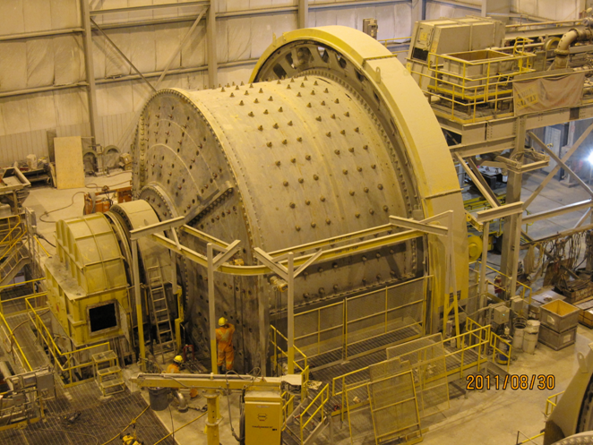

Source: Company files.

Exhibit 4: Typical Mining Mill and Cutaway, showing Liner

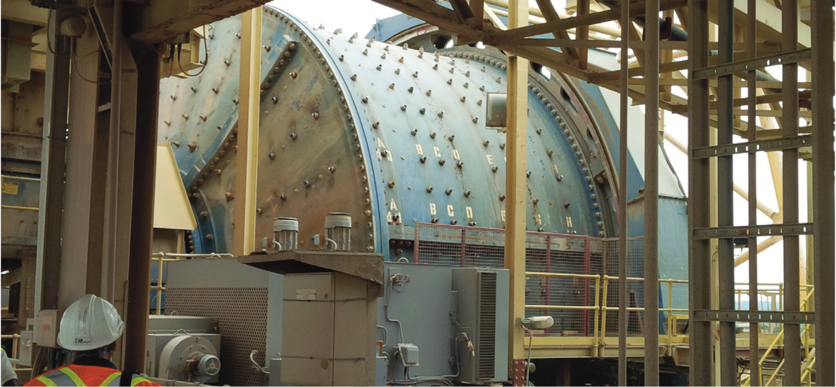

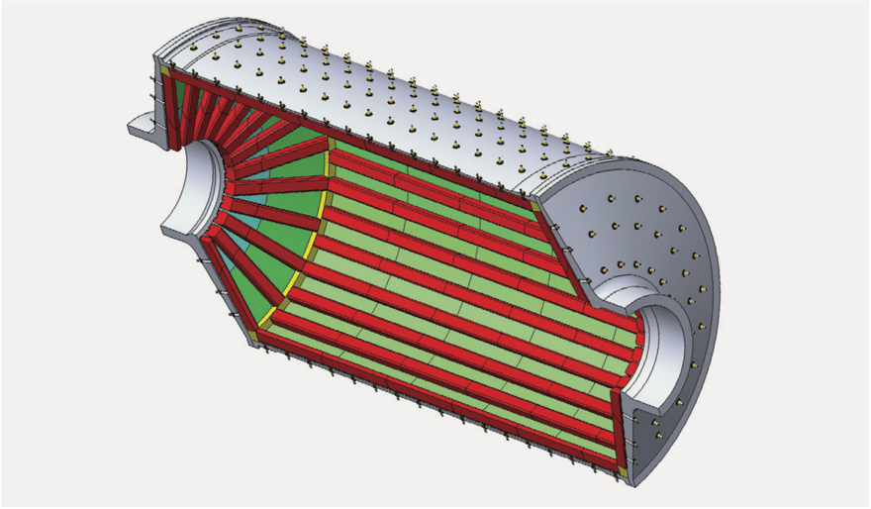

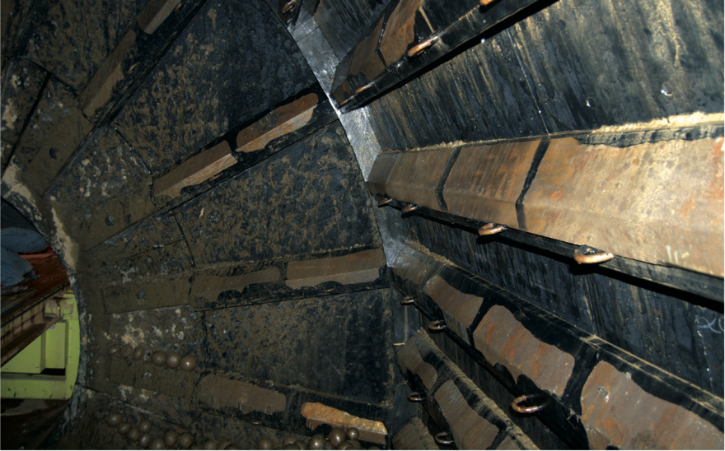

Source: Company files.

Exhibit 5: Polycorp’s Changing Competitive Environment

Source: Company files.

Exhibit 6: Metso Minerals’ Mining Division, Abbreviated Income Statement, 2015

|  | **€ millions** | **% of Sales** |
| --- | --- | --- |
| Total Sales | 2,198 | 100% |
| Services Sales | 1,437 | 65% |
| Adjusted EBITA | 241 | 11% |
| Operating Profit | 213 |  |
| Gross Capital Expenditure | 29 |  |
| Research and Development Expenditures | 17 |  |

Note: EBITA = earnings before interest, taxes, and amortization.

Source: *Metso 2015 Annual Review*, 26, https://www.mogroup.com/globalassets/investors/reports/2015/metso_annual_review_2015.pdf

Exhibit 7: Weir Group’s Minerals Division, Abbreviated Income Statement, 2015

|  |  |  |
| --- | --- | --- |
|  | **£ millions** | **% of Sales** |
| Total Revenue | 1,034 | 100.0% |
| Original Equipment Revenue | 304 | 29.0% |
| Aftermarket Services Revenue | 730 | 71.0% |
| EBITA | 198 | 19.2% |

Note: EBITA = earnings before interest, taxes, and amortization.

Source: The Weir Group, *2015 Full Year Results: Progress in Challenging Markets*, 2016, https://www.global.weir/assets/files/investors/presentations/FY15%20Roadshow%20Presentation.pdf.

Exhibit 8: Polycorp’s Mining Division, Forecast and Income Statement, 2016

|  | **CA$** | **% of Sales** |
| --- | --- | --- |
| Total Sales | 42,782,974 |  |
| Total Cost of Sales | 23,118,885 |  |
| Contribution after Cost of Sales | 19,664,089 | 46.0% |
| Freight and Customs Costs | 803,067 | 1.9% |
| Gross Contribution | 18,861,022 | 44.1% |
| Selling Expenses | 7,558,173 | 17.7% |
| Net after Selling Expenses | 11,302,849 | 26.4% |

Source: Company files.

1. All dollar amounts are in Canadian dollars unless otherwise indicated.
2. Nils Pratley, “Global Mining Industry Faces Up to a Deep Malaise,” *Guardian*, July 24, 2015, http://www.theguardian.com/business/2015/jul/24/global-mining-industry-faces-up-to-a-deep-malaise.
3. Peter Koven, “Anglo American’s Massive Restructuring Involving 85,000 Layoffs Shows Miners Bracing for Prolonged Downturn,” *Financial Post*, December 8, 2015, http://business.financialpost.com/news/mining/anglo-american-to-cut-85000-workers-sell-60-of-its-assets-and-suspend-dividend.
4. Koven, “Anglo American’s Massive Restructuring.”
5. Alexandra Sheehan, “Opportunity Knocks: 9 Niche Market Examples with Untapped Business Potential,” *Shopify* (blog), April 11, 2021, https://www.shopify.ca/blog/niche-markets.
6. Canadian Chamber of Commerce and Grant Thornton LLP, “Leading Manufacturer Polycorp Ltd. Selected As 2014 *Private Business Growth Award* Winner,” press release, Business Wire, November 20, 2014, https://www.businesswire.com/news/home/20141120005963/en/Leading-Manufacturer-Polycorp-Ltd.-Selected-as-2014-Private-Business-Growth-Award-Winner.
7. John O’Hanlon, “Polycorp Ltd.,” *Business Excellence*, April 2013, https://www.bus-ex.com/article/polycorp-ltd.
8. Fernie Grace Tiflis, “Built-to-Last Rubber Back Polycorp’s Success,” *Manufacturing Today,* July/August 2006*,* http://www.poly-corp.com/assets/pdf/corporate/August-2006-Manufacturing-Today.pdf.
9. Tiflis, “Built-to-Last.”
10. Tiflis, “Built-to-Last.”
11. Metso Minerals merged with Outotec Oyj to form Metso Outotec Oyj after the date of this case. Metso Outotec, “Metso Outotec and Neles: Now Independent Companies,” press release, July 1, 2020, https://www.metso.com/news-metso-outotec-neles.
12. Metso Outotec, “Metso Outotec and Neles Now Independent Companies.”
13. € = EUR = euros; €1 = CA$1.59187 as of January 18, 2016.
14. Metso Corporation, *Metso 2016: Annual Review*, 2, 2017, https://www.metso.com/siteassets/annual-report/new-files/metso_annual_review_2016_2.pdf.
15. Metso Corporation, *Metso 2015 Annual Review*, 16, 2016, https://mb.cision.com/Main/19005/2977212/1153180.pdf.
16. Metso Corporation, *Metso 2015 Annual Review*, 2, 18.
17. Metso, “Metso Is Investing in Mill Linings Manufacturing to Strengthen Its Global Services Capability,” Mining [Dot] Com, August 22, 2012, https://www.mining.com/web/metso-is-investing-in-mill-linings-manufacturing-to-strengthen-its-global-services-capability/.
18. “TA Associates Buys Minority Stake in Tega Industries for $40 Million,” *Business Standard*, January 20, 2013, https://www.business-standard.com/article/press-releases/ta-associates-buys-minority-stake-in-tega-industries-for-40-million-111051200149_1.html.
19. Tega Industries Limited, “Who We Are,” Tega, accessed March 15, 2021, https://www.tegaindustries.com.
20. Tega Industries Limited, “About Us,” Tega, accessed April 15, 2021, https://www.tegaindustries.com/about-us/.
21. “Tega Industries,” Glassdoor, accessed November 24, 2020, https://www.glassdoor.ca/Overview/Working-at-Tega-Industries-EI_IE274555.11,26.htm.
22. The Weir Group PLC, *Progress in Challenging Markets: Annual Report and Financial Statements 2015*, accessed April 15, 2021, https://www.global.weir/assets/files/investors/reports/The%20Weir%20Group%20PLC%20Annual%20Report%20and%20Financial%20Statements%202015.pdf.
23. The Weir Group PLC, “Wear Lining and Corrosion Protection: Our Materials Have You Covered,” Weir, accessed November 24, 2020, https://www.global.weir/industries/mining/processes/wear-lining-and-corrosion-protection.
24. The Weir Group PLC, *Progress in Challenging Markets*.
25. Metso Outotec, “Metso Outotec and Neles Now Independent Companies.”
26. Formerly the China International Trust Investment Corporation.
27. Cecilia Jamasmie, “Hitachi Construction to Buy Australia’s Bradken for $528 Million,” Mining [Dot] Com, October 3, 2016, https://www.mining.com/hitachi-construction-to-buy-australias-bradken-for-528-million.